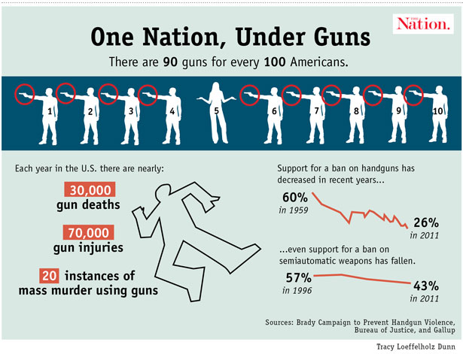

**Think about:**

* What your point of view is
* How to write an introduction to clearly state what your opinion about the topic
* What your arguments are with reasons, evidence and examples to explain them
* How to be persuasive (using devices which are appropriate such as herd mentality and high modality words etc.)
* A rebuttal and writing a conclusion to provide a summary of you main arguments and opinion.

Remember to:

* Plan your writing before you begin (think about the tier 2 and 3 words you would like to incorporate)
* Make your writing engaging to read
* Write sentences which stay on the topic
* Check your spelling and punctuation
* Start a **NEW** paragraph for each idea/reason
* Re-read and edit your writing at the end

***Look carefully at the pictures; they may help you with some ideas***

American gun laws should be changed!